F.61 -

Functionality
This function controls the output of correspondence requests by calling up the print reports on a company code basis for the individual correspondence requests. After processing the correspondence requests are deleted.
The program is usually scheduled as a job once a day so that the correspondence requests that have accumulated in the meantime can be output.

Scenario
Some correspondence requests for the customers within your company code were issued and now you’ve decided to print them out.

Requirements
Correspondence requests

Menu Path | Accounting → Financial Accounting → Accounts Receivable → Periodic processing → Print correspondence → F.61 - As per requests
Transaction Code | F.61

1. Double click on F.61 - As per requests

Trigger for Correspondence

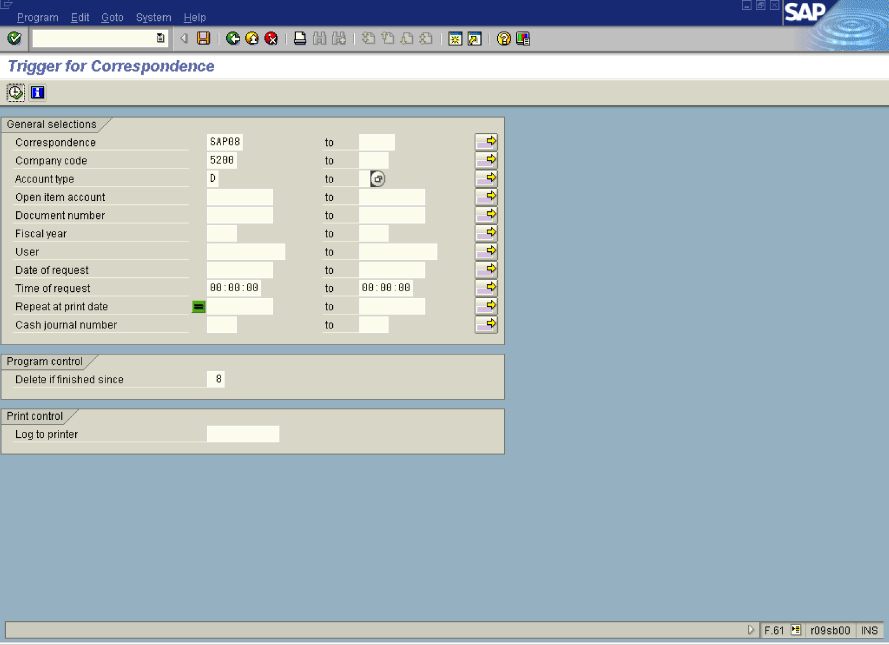

2. Update the following fields:

Field Name | Field Description | Values
Correspondence | A correspondence type (for example, payment notice or account statement) | Example: SAP08
Company code | Code identifying a separate legal entity for which a separate set of accounts is maintained for external reporting purposes | Example: 5200
Account type | Code identifying the type of account or subledger | Example: D

3. Click Enter Button to confirm your entries.

4. Click Execute button The system will search for existing correspondence requests that fulfill criteria:

Correspondence requests

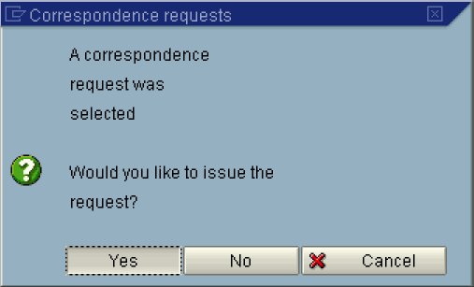

5. Click Yes .

Trigger for Correspondence

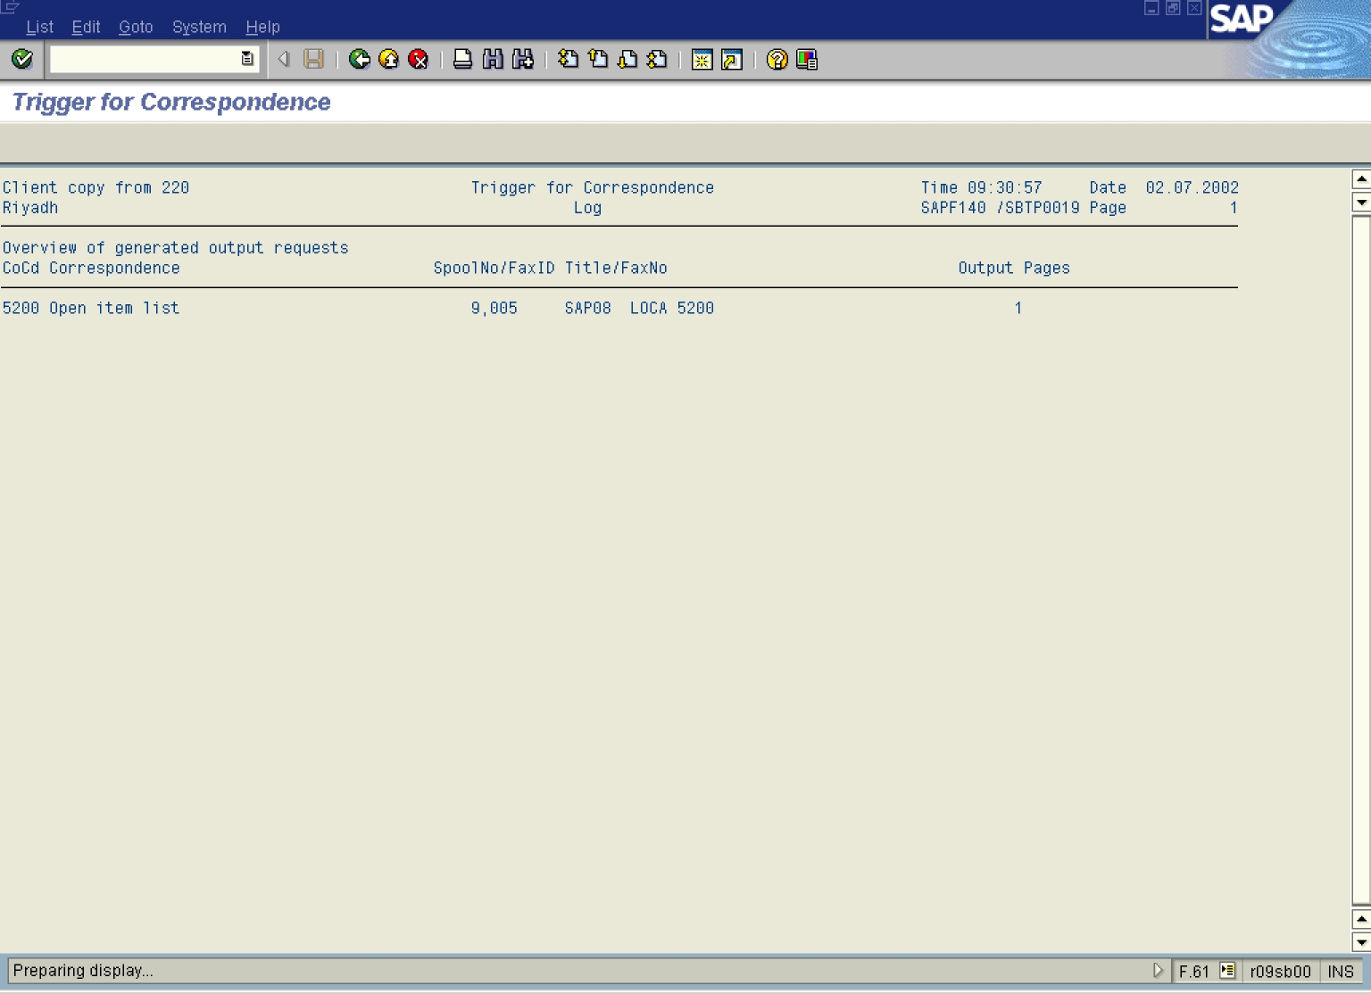

Note: The system has created a spool request. To print the required correspondence forms you need to display the print jobs.

6. Enter in the command line /nsp02. The system will display a list of spool requests (print jobs):

Output Controller: List of Spool Requests

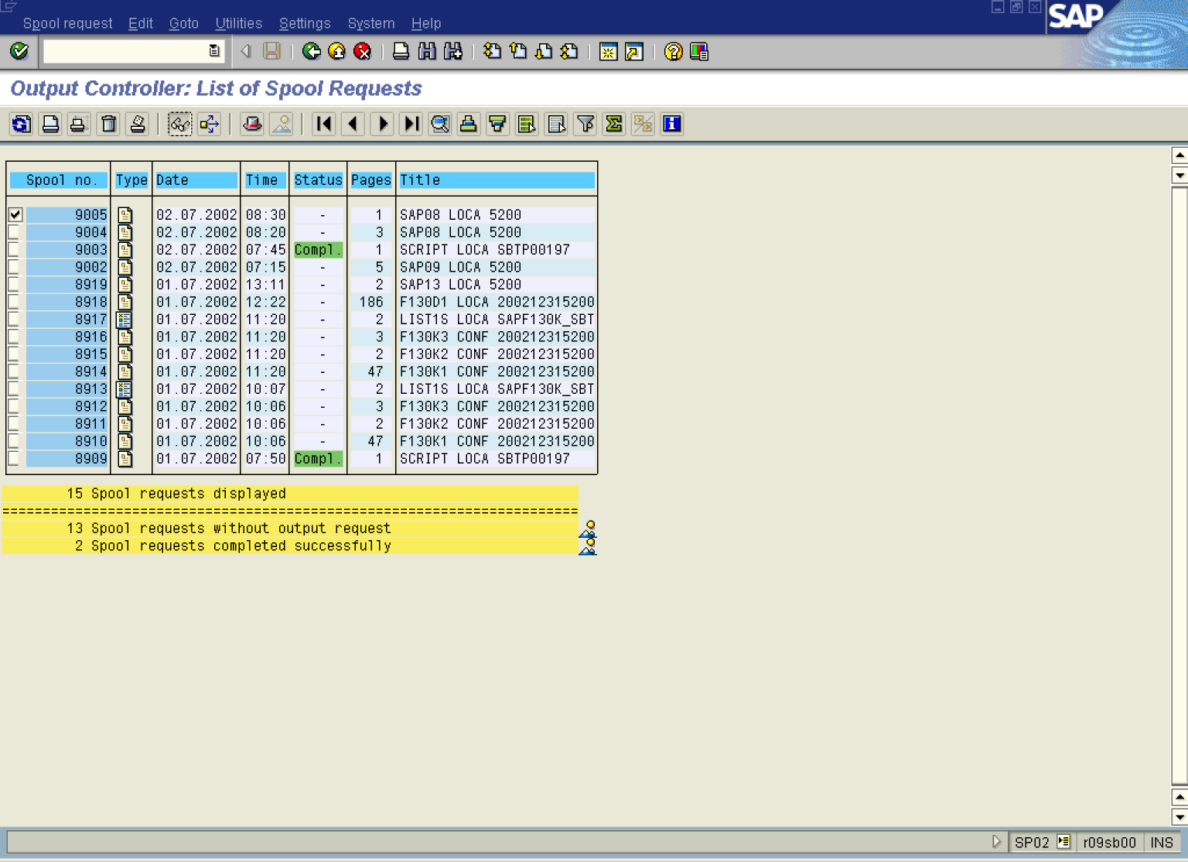

7. To select your print job, click on its name: 9005 .

8. You can display printout preview: click Display contents Button .

Print Preview for LOCA Page 00001 of 00001

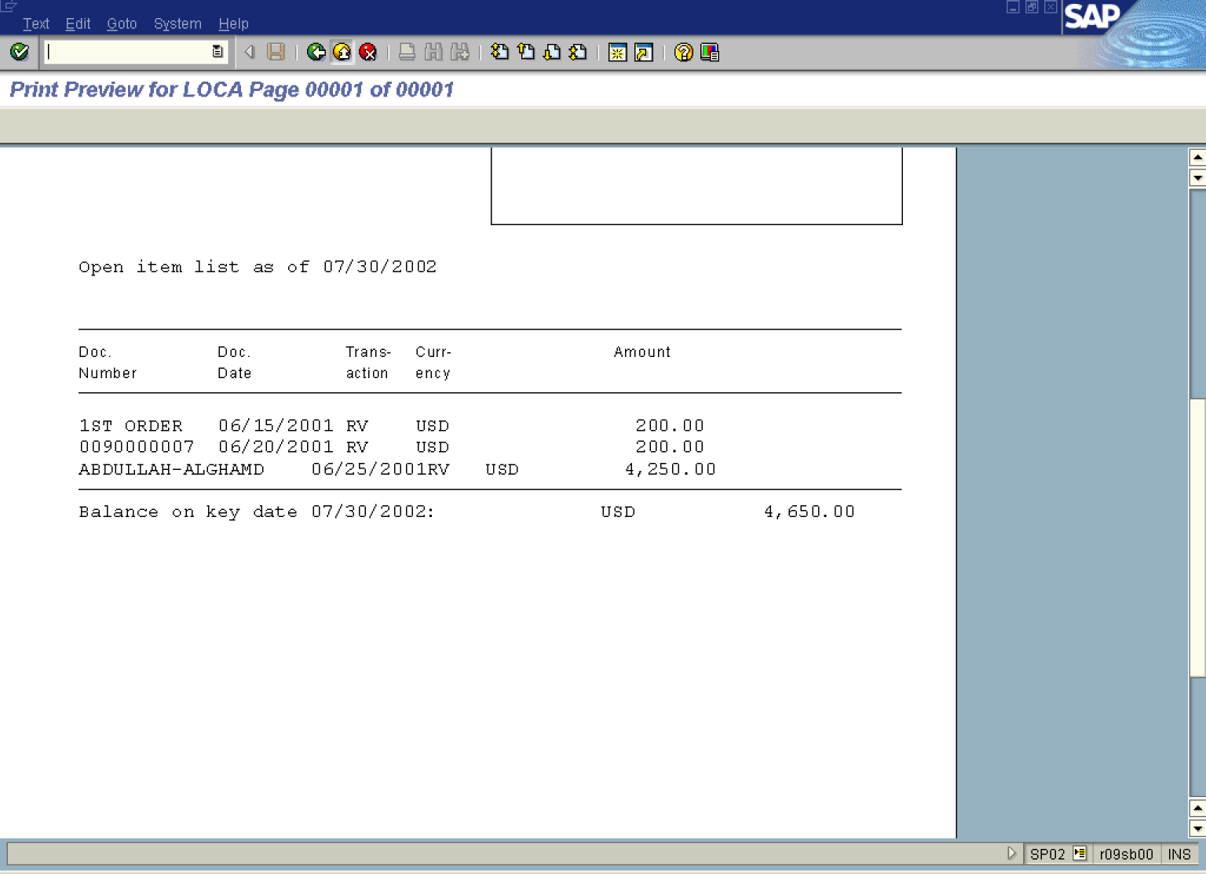

9. Click Back Button .

Output Controller: List of Spool Requests

10. If you want to print the correspondence requests, press Print button.

